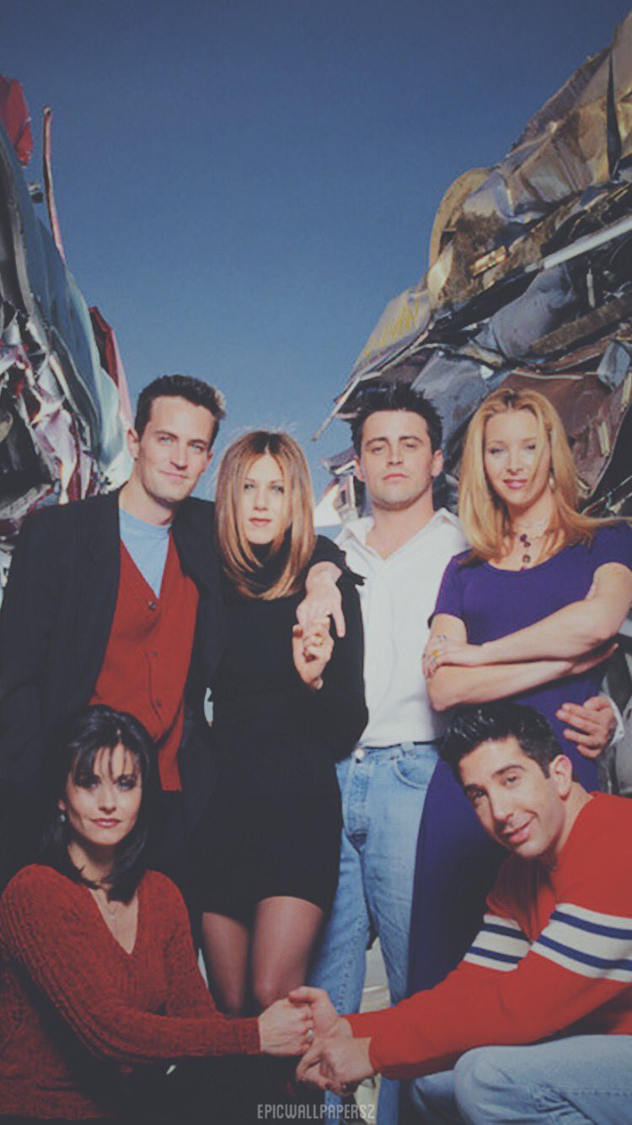

C FOUR SITE

“PICS THAT WERE TOGETHER”

BACK TO TOP

ABOUT US

HOME

CONTACT US

FOUR SITE

